

***Hands-On Exercise 6.2 [20-points]:Non-Recursive Power***

### *Instructions:*

* According to some research, industry values documentation, and excellent written and oral communication skills. The purpose of this part of the class is to encourage you to gain these skills.
* Backup your work to your USB drive for this material may come out as part of your examination.
* Make a copy of this entire document and add your work into it.
* Submit to Blackboard at the same link where you got this document.
* Points will be a deducted if submitted on the wrong place, or if these instructions are not followed.

***IDE structure:***

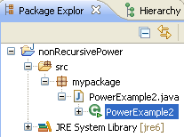

1.❑ Add PowerExample2 class and type the code below

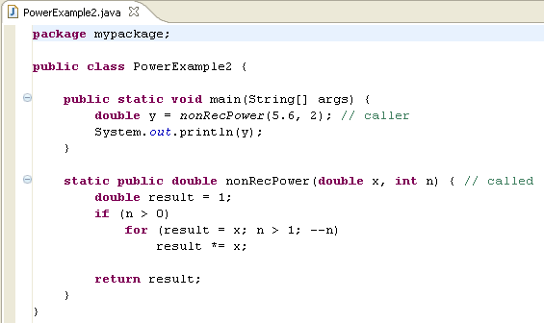

2.❑ Paste your code here.

**package** Exercise6_2;

**public** **class** PowerExample {

**public** **static** **void** main(String[] args) {

**double** y = *nonRecPower*(5.6, 2);

System.***out***.println(y);

}

**static** **public** **double** nonRecPower(**double** x, **int** n){

**double** result = 1;

**if**(n > 0)

**for**(result = x; n > 1; --n)

result *= x;

**return** result;

}

}

3.❑ Paste your screen shot output here [Ctrl] + [PrtScn]. Make sure you magnified it. It should be similar to this:

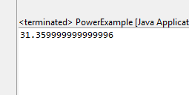

4.❑ Write your topmost question regarding this topic.

Is recursion still recursion if it is used with same names methods with different signatures?

5.❑ **Critical Thinking:** If you are asked to make a test question based on this topic, what would be the question and what is your answer?

Which is faster, iterative looping or recursion? Answer: Iterative looping.

[](http://images.google.com/imgres?imgurl=www.skyscript.co.uk/im/trophy.jpg&imgrefurl=http://www.skyscript.co.uk/im/&h=214&w=180&sz=6&tbnid=ECCiP8U-7NsJ:&tbnh=99&tbnw=84&prev=/images?q=trophy&svnum=10&hl=en&lr=&ie=UTF-8&oe=UTF-8&sa=G) Congratulations! You’ve just learned the equivalent implementation of powers without using recursive functions.

**Submission Procedure**

1. Write your **name** here: _Joshua LeGoff________________
2. Date: __10/30/2015_____________
3. **Backup** your work to your USB drive, this material may come out as part of your exam.
4. **Submit** to Blackboard at the link where you got it.

**Note:**

* Submit back to Blackboard where you get it.
* 2-points deduction if you submit it on the wrong place.
* 2-points deduction if you did not follow these instructions.
* Make sure you submit it at the correct location where you got it.

|  |  |  |  |  |
| --- | --- | --- | --- | --- |
| GRADING RUBRIC | | | | |
| Grading Criteria | 3  **Exceeds**  *Excellent*  Epic Wow | 2  **Meets**  *Satisfactory*  O.K. | 1  **Partially Meets**  *Below Expectations*  Not Yet | 0  **Does Not Meet**  *Unacceptable*  Fail |
| **Completeness** | +5-Completed all the required work and added more examples. | +2-Completed all the work required. | +1-Partially completed the work required. | Unfortunately, did not complete the work required. |
| **Coding** | +10- Code is excellent, comments are added, and different techniques were used. | +7-Code is O.K., and program works. | +4-Code works, but still needs improvement. | Unfortunately, no coding. |
| **Output** | +5-Outputs are correct, and provided additional output cases. | +2-Output meets requirement and is readable. | +1-There is output, but not readable, and/or needs improvement. | Unfortunately, no output. |
| **Late** | Excellent, you submitted it before the deadline. | -5, unfortunately for submitting after the deadline. | -7, unfortunately for submitting several weeks after the deadline. | -10, unfortunately, for submitting very late. |